**Dungeness steelhead spawn timing, scales, DNA samples**

From: Randy Cooper

12/6/2016

To: Bethany Craig, Mike Gross, Chris Burns, Pete Topping, Joe Anderson

Hi Bethany,

Per our phone conversation yesterday, I have attached Dungeness River steelhead escapement estimates and DNA/scale sample data collected by Chris Burns, Jamestown S’Klallam Tribe. I have attached some maps in jpg files to show you the area covered for most salmon and steelhead surveys within the drainage.

The Dungeness can be frustrating to survey in the spring. The file, “Copy of Steelhead Spring 2015”, shows the 2015 data being used to develop the spawning timing curve for this stock. I guess the 2015 drought year was good for something.  It is difficult to do spawner surveys in the Dungeness when river flows are above 325-350 cfs especially in the upper watershed. Please look at the two graphs below. The top graph shows the Dungeness River flows during the spring of 2016 and the bottom graph for 2015. What a difference a year makes. Surveys couldn’t be conducted in 2016 due to high flows (>325-350 cfs); whereas in 2015, flows were <325-350 cfs most of the spring. Ideally, I would like to clone consultant, Keith Denton, and have him use his expertise with SONAR to estimate steelhead returns on the Elwha and Dungeness at the same time.

   2016 Dungeness River

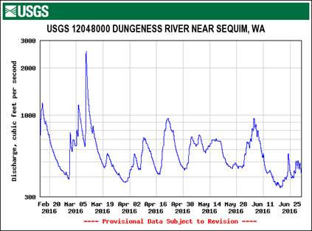

    2015 Dungeness River (drought year)

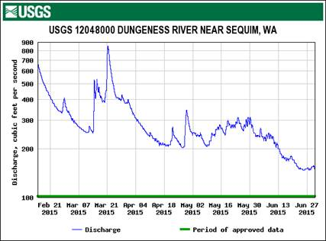

Originally, the first attempt at an expansion method for estimating steelhead spawning timing in the Dungeness River was based on nearby watersheds with a long-term data series. We used the Quillayute System (Sol Duc, Bogachiel, Calawah) spawning timing curve since it had data going back to the late 1970s-early 1980s. This data series consisted of new redd counts by date and statistical week over several years. To make a long story short, the 2015 drought year allowed Chris and his staff to survey the Dungeness throughout most of the year.  This 2015 data set was used to replace the Quillayute spawning timing curve. Another change to the expansion methodology was made when fish consultant, Mike Haggerty, suggested to Chris to use Julian date instead of statistical week to make the survey data more uniform. In the Steelhead Spring 2015 file, you can see the redd counts by index section labeled with upper and lower river mile locations. The last worksheet “Charts” shows the spawning timing curves for each index section. I am planning to revisit historical Dungeness steelhead surveys and applying this new expansion methodology with the hope of developing meaningful expansion estimates.

That’s all for now and congratulations on your new position within Fish Program.

RC